Winter Camp IFK Belgium

Friday 04 March 2022

Until

Sunday 06 Sunday 2022

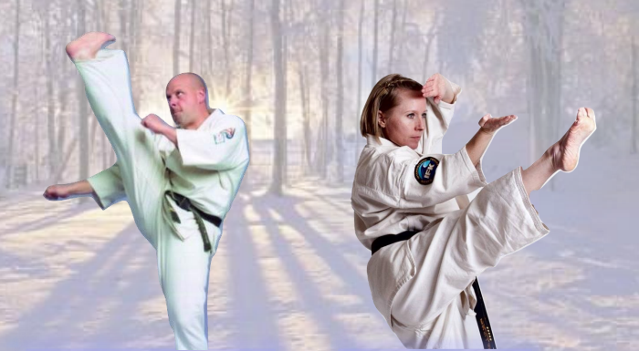

Shihan Andrew Turner (6th dan)
Shihan Janine Davies (6th dan)

Venue : Sport Vlaanderen Hofstade
Tervuursesteenweg (no number), 1981 Hofstade, Belgium
www.sportvlaanderen.be

Arrival : Check-in on Friday 04/03/2022 from 1900 hrs in Sporthotel Sport Vlaanderen Hofstade.

Parking : Parking area is nearby the Sporthotel.

Buildings : Sporthotel Sport Vlaanderen Hofstade.
Rooms will be assigned. Showers and toilet are provided in every room.

A bed, bedding and a pillow are provided.

A recreational room is available in the Sporthotel.
A cafeteria is available at the sports hall.

The night's rest of the other groups in the domain must be respected
between 2200 and 0800 hrs.

The rooms must be vacated on Sunday, no later than 1400 hrs.

Bedding needs to be left in the hallway.

Luggage can be stored in the Sporthotel if necessary.

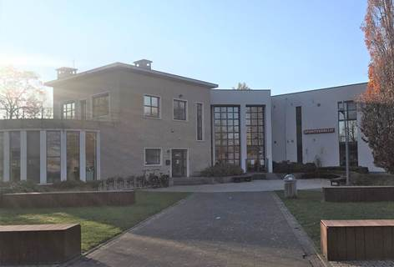

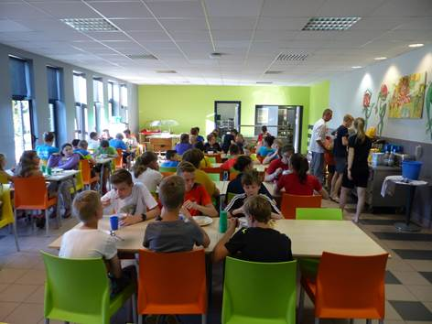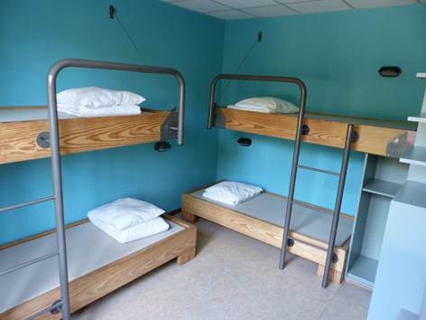

Clothing : 2 dogi.
Shin pads, gloves, etc ...
Running shoes and outdoors clothing are required.
If possible, please bring 1 pad for every 2 participants.

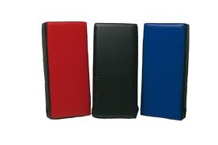

Schedule : The training schedule can be adjusted according to necessities.
During a number of sessions every participant can choose which class he/she would like to attend. These sessions are marked with *
Friday 04/03/2022

from | until | training | location
2000 | 2400 | Grading – Shihan Andrew | sports hall
2000 | 2400 | General training – Shihan Janine | outside

Saturday 05/03/2022

from | until | training | location
0700 | 0745 | warming up – Shihan Andrew | outside
0800 | 0900 | breakfast | restaurant
0930 | 1030 | general training – Shihan Janine | sports hall
1030 | 1130 | kihon low grades – Shihan Janine * | sports hall
 |  | kihon high grades – Shihan Andrew *
1200 | 1300 | lunch | restaurant
1400 | 1500 | general training – Shihan Andrew | sports hall
1500 | 1600 | basic fighting techniques by Shihan Andrew * | sports hall
 |  | kata high grades by Shihan Janine *
1600 | 1700 | advanced fighting techniques - Shihan Andrew * | sports hall
 |  | kata low grades by Shihan Janine *
1800 | 1900 | dinner | restaurant
2000 | ??? | group activity | ???

Sunday 06/03/2022

from | until | training | location
0700 | 0745 | warming up - Shihan Janine | outside
0800 | 0900 | breakfast | restaurant
0930 | 1030 | general training - Shihan Andrew | sports hall
1030 | 1130 | pads training - Shihan Andrew * | sports hall
 |  | kata training - Shihan Janine * | sports hall
1200 | 1300 | lunch | restaurant
1400 | 1500 | warming up - Shihan Andrew | sports hall
1500 | 1700 | sparring | sports hall
1700 | 1800 | end camp – pictures etc … | sports hall

The training will take place outside or in the gym, as indicated.
Pay attention to the weather (rain - cold) and the wooded area (sandy soil).
The sports hall is shown on the plan and is about 5 minutes walk from the
sporthotel. There are changing rooms available in the sports hall. It is advised to
change in the changing rooms to keep your dogi clean.

Departure : Check-out on Sunday 09/02/2020, after finishing the last training session.
The hostel is the latest to be abandoned at 1400 hrs.

Age : From 12 years old.

Cost : 130 euro for the whole weekend.
The cost includes all training, accommodation and meals
(no meals on Friday and Sunday evening).
Daily price of 35 euros for Saturday or Sunday.
This price includes training in the morning (0930 - 1130 hours), lunch and
training in the afternoon (1400 - 1700 hours).
Deviations from the planned stay is possible, please contact Shihan Benny (contact details below) considering the cost price will be dependent on the timing of arrival / departure and consumed meals.
However, it goes without saying that we would like to welcome you all weekend!

Payment : We would like to receive payments grouped by dojo. Please mention the name of
your dojo and the number of participants when transferring your registration fee.
We would like to receive your payment (full amount) before February 1st, 2022
on the account of :
Sutani Dojo VZW, Ternesselei 237, 2160 Wommelgem, Belgium.
IBAN : BE83 7330 6155 4715
BIC : KRED BE BB

Registration : Please use the attached form for registration.
Your participation is recorded only upon receipt of the full amount and no later than
February 1st, 2022.
The number of rooms is limited. We apply the principle of first come, first served!

Contact : Shihan Benny Geluykens, Sutani Dojo, IFK Belgium.
bestuur@kyokushin.be
0032 473 828231

sports hall

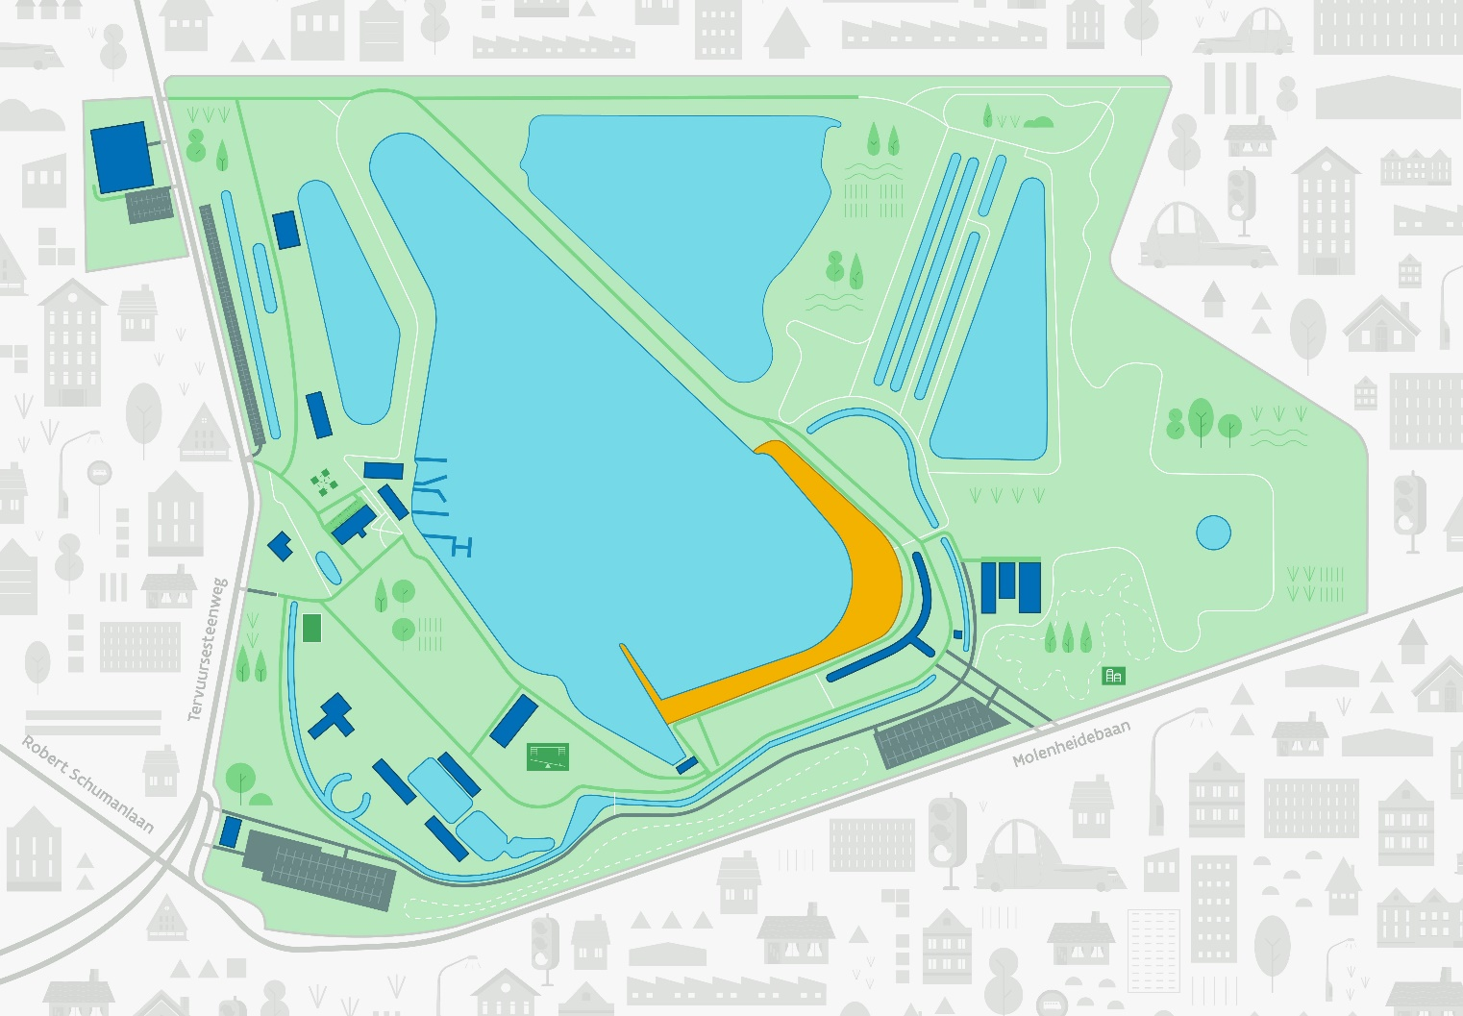
hostel
parking

